The Java do-while loop is used to iterate a block of code repeatedly, until the specified condition is true. If the number of iterations is not fixed and you must have to execute the loop at least once, it is recommended to use a do-while loop. The do-while checks the condition at the end of loop body and therefore is executed at least once.

Syntax:

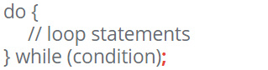

**NOTE:** There is a semi colon at the end, after the parenthesis of the condition.

Block Diagram:

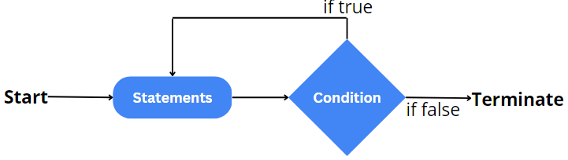

Example:

